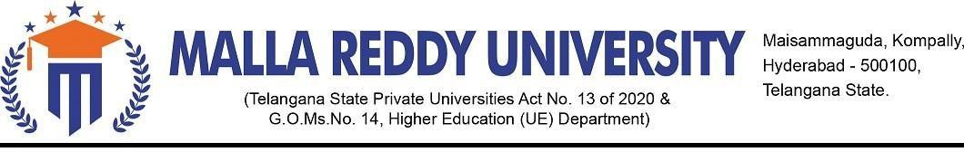

**DEPARTMENT OF COMPUTER SCIENCE & ENGINEERING B.TECH – II YR – I SEM(2024-25)**

**APPLICATION DEVELOPMENT – JAVA EXPLORE**

**TITLE OF THE APPLICATION: UNICART**

**DOMAIN: MARKETING**

**BATCH DETAILS:**

1. **Batch Name & Number:** Group -2 & AD-69
2. **Student details:**

**Name of the Student Hall Ticket Number**

1. G.VEDANSH REDDY 2311CS010244
2. K.SAI THARUNI 2311CS010290
3. V.TEJA 2311CS010677
4. V.SRINIVASA CHARI 2311CS010680
5. Y.MANASA 2311CS010708

**GUIDE NAME : Mrs. G. Devi Priya**

**ABSTRACT :**

This project presents an innovative, all-in-one platform designed to streamline the process of ordering food and enhance the shopping experience by integrating a wide range of products and services into a single, user-friendly interface. The platform offers a comprehensive selection of groceries, accessories, gadgets, and other essential items, providing detailed information on each product to assist customers in making informed purchasing decisions. One of the standout features of the platform is its emphasis on rapid delivery, ensuring that users receive their orders in the shortest time possible. The system is designed to enhance overall shopping experience for customers.By combining diverse product offerings with exceptional convenience and speed.This project aims to set a new standard for online shopping, catering to the dynamic needs of modern consumers.

**TOOLS USED : MongoDB, Node.js, Express.js, React.js, VS code**

**SIGNATURE OF GUIDE SIGNATURE OF COORDINATOR**

**(Mrs. G. Devi Priya) (MR. M. RAKESH**)